Use Case Specification Report

**Use Case Specification**

Casos de Uso

Revision: 0.2

marzo 25, 2019

Approval

|  |
| --- |
| The original of this document is approved and signed by:  Name: Cristina  Surname:Perales  Title: Casos de Uso  Date: 25/03/2019  Signature: |

Revision History

|  |  |  |  |
| --- | --- | --- | --- |
| **Revision** | **Date** | **Description** | **Author** |
| 0.1 | <date 1> | <draft> | <Author name> |
| 0.2 | <date 2> | <release> | <Author name> |

Table of Contents

Microsoft Word users please click here and press F9 to create Table of Contents.

OpenOffice.org users please remove this text and select Insert Table of Content from menu.

Index of Use-Cases

|  |  |
| --- | --- |
| **UseCase** | **Page** |
| Crear comentarios nuevos | Error! Bookmark not defined. |
| Crear Cuenta | Error! Bookmark not defined. |
| Desarrollar el Software | Error! Bookmark not defined. |
| Eliminar cuenta | Error! Bookmark not defined. |
| Eliminar posibles errores del Software | Error! Bookmark not defined. |
| Iniciar sesión | Error! Bookmark not defined. |
| Modificar Software | Error! Bookmark not defined. |
| Observar los comentarios | Error! Bookmark not defined. |
| Poner datos personales | Error! Bookmark not defined. |
| Tipos de vehículos | Error! Bookmark not defined. |
| Visibilidad del soporte | Error! Bookmark not defined. |

# Introduction

## Purpose

<This Document describes Use Case Specification Report.>

## Scope

<This Document intends to describe use case specification for the system.>

## Overview

<Describe what the document contains and explain how the document is organized.>

# Actor Summary

|  |  |
| --- | --- |
| **Primary Actor** | **Use Cases** |
| Cliente | * Crear comentarios nuevos      * Crear Cuenta      * Eliminar cuenta      * Iniciar sesión      * Observar los comentarios      * Poner datos personales      * Tipos de vehículos      * Visibilidad del soporte |
| Desarrollador | * Desarrollar el Software      * Eliminar posibles errores del Software      * Modificar Software      * Visibilidad del soporte |
| Mecánico | * Crear comentarios nuevos |

# Use Case: Actores Diagram

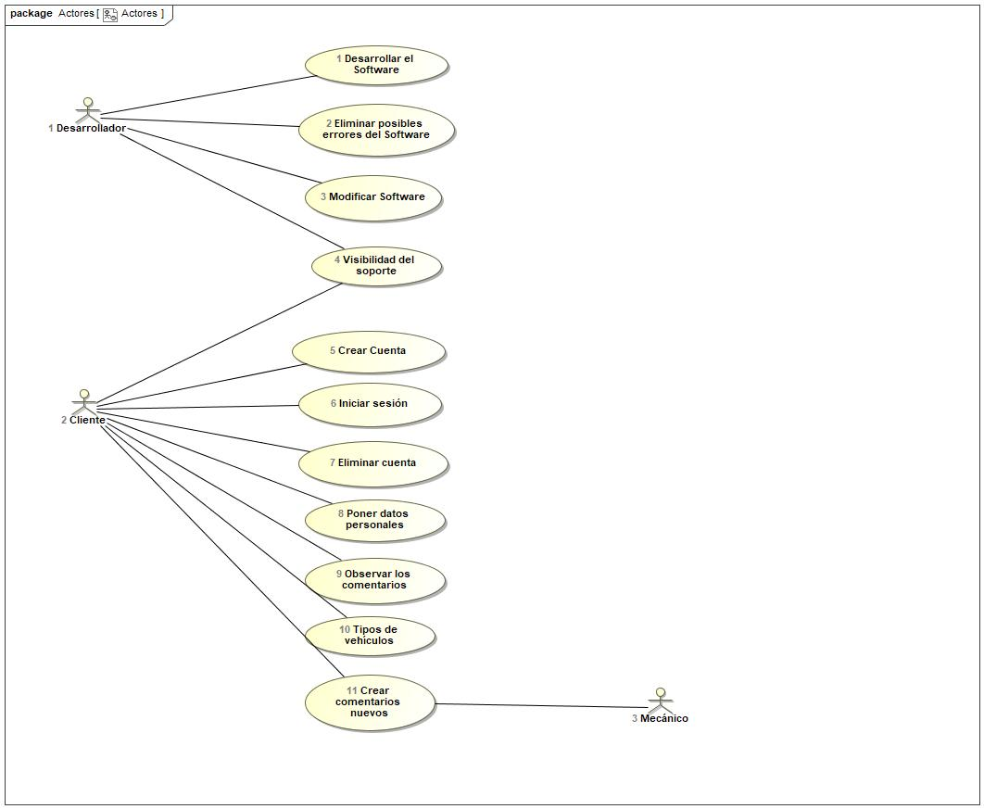

## Crear comentarios nuevos Use Case

|  |  |  |  |
| --- | --- | --- | --- |
| **Use Case Name** | Crear comentarios nuevos | ID | 11 |
| **Complexity** | Average Complexity | | |
| **Description** |  | | |
| **Actors** | * Cliente * Mecánico | | |
| **Goal** |  | | |
| **Assumption** |  | | |
| **Non Functional Requirements** |  | | |
| **Pre Condition** |  | | |
| **Post Condition** |  | | |
| **Constraints** |  | | |

|  |  |
| --- | --- |
| **Relations** | |
| **Association** | * Cliente Actor * Mecánico Actor |
| **Include** |  |
| **Extend** |  |
| **Generalization** |  |

|  |  |
| --- | --- |
| **Scenarios** | |
| **Basic Flow of Events** |  |
| **Basic Flow of Events Diagrams** |  |
| **Alternative Flow of Events** |  |
| **Alternative Flow of Events Diagrams** |  |
| **Exceptional Flow of Events** |  |
| **Exceptional Flow of Events Diagrams** |  |

## Crear Cuenta Use Case

|  |  |  |  |
| --- | --- | --- | --- |
| **Use Case Name** | Crear Cuenta | ID | 5 |
| **Complexity** | Average Complexity | | |
| **Description** |  | | |
| **Actors** | * Cliente | | |
| **Goal** | Cuenta en el Software | | |
| **Assumption** |  | | |
| **Non Functional Requirements** |  | | |
| **Pre Condition** | Todos los usuarios tienen la posibilidad de poder crearse una cuenta. | | |
| **Post Condition** | Todas las cuentas estarán almacenadas en la base de datos con los respectivos datos personales. | | |
| **Constraints** |  | | |

|  |  |
| --- | --- |
| **Relations** | |
| **Association** | * Cliente Actor |
| **Include** |  |
| **Extend** |  |
| **Generalization** |  |

|  |  |
| --- | --- |
| **Scenarios** | |
| **Basic Flow of Events** |  |
| **Basic Flow of Events Diagrams** |  |
| **Alternative Flow of Events** |  |
| **Alternative Flow of Events Diagrams** |  |
| **Exceptional Flow of Events** |  |
| **Exceptional Flow of Events Diagrams** |  |

## Desarrollar el Software Use Case

|  |  |  |  |
| --- | --- | --- | --- |
| **Use Case Name** | Desarrollar el Software | ID | 1 |
| **Complexity** | Average Complexity | | |
| **Description** |  | | |
| **Actors** | * Desarrollador | | |
| **Goal** | Diseñar un modelo de Software. | | |
| **Assumption** |  | | |
| **Non Functional Requirements** |  | | |
| **Pre Condition** | El desarrollador está contentado al soporte. | | |
| **Post Condition** | Se genera un nuevo Software. | | |
| **Constraints** |  | | |

|  |  |
| --- | --- |
| **Relations** | |
| **Association** | * Desarrollador Actor |
| **Include** |  |
| **Extend** |  |
| **Generalization** |  |

|  |  |
| --- | --- |
| **Scenarios** | |
| **Basic Flow of Events** |  |
| **Basic Flow of Events Diagrams** |  |
| **Alternative Flow of Events** |  |
| **Alternative Flow of Events Diagrams** |  |
| **Exceptional Flow of Events** |  |
| **Exceptional Flow of Events Diagrams** |  |

## Eliminar cuenta Use Case

|  |  |  |  |
| --- | --- | --- | --- |
| **Use Case Name** | Eliminar cuenta | ID | 7 |
| **Complexity** | Average Complexity | | |
| **Description** |  | | |
| **Actors** | * Cliente | | |
| **Goal** | Eliminar cuenta. | | |
| **Assumption** |  | | |
| **Non Functional Requirements** |  | | |
| **Pre Condition** | Eliminar los datos que estén en la base de datos. | | |
| **Post Condition** | No está registrado en el sistema. | | |
| **Constraints** |  | | |

|  |  |
| --- | --- |
| **Relations** | |
| **Association** | * Cliente Actor |
| **Include** |  |
| **Extend** |  |
| **Generalization** |  |

|  |  |
| --- | --- |
| **Scenarios** | |
| **Basic Flow of Events** |  |
| **Basic Flow of Events Diagrams** |  |
| **Alternative Flow of Events** |  |
| **Alternative Flow of Events Diagrams** |  |
| **Exceptional Flow of Events** |  |
| **Exceptional Flow of Events Diagrams** |  |

## Eliminar posibles errores del Software Use Case

|  |  |  |  |
| --- | --- | --- | --- |
| **Use Case Name** | Eliminar posibles errores del Software | ID | 2 |
| **Complexity** | Average Complexity | | |
| **Description** |  | | |
| **Actors** | * Desarrollador | | |
| **Goal** | Corregir los errores encontrados | | |
| **Assumption** |  | | |
| **Non Functional Requirements** |  | | |
| **Pre Condition** | Puede prevenir errores del sistema. | | |
| **Post Condition** | Mejora la condición del Software. | | |
| **Constraints** |  | | |

|  |  |
| --- | --- |
| **Relations** | |
| **Association** | * Desarrollador Actor |
| **Include** |  |
| **Extend** |  |
| **Generalization** |  |

|  |  |
| --- | --- |
| **Scenarios** | |
| **Basic Flow of Events** |  |
| **Basic Flow of Events Diagrams** |  |
| **Alternative Flow of Events** |  |
| **Alternative Flow of Events Diagrams** |  |
| **Exceptional Flow of Events** |  |
| **Exceptional Flow of Events Diagrams** |  |

## Iniciar sesión Use Case

|  |  |  |  |
| --- | --- | --- | --- |
| **Use Case Name** | Iniciar sesión | ID | 6 |
| **Complexity** | Average Complexity | | |
| **Description** |  | | |
| **Actors** | * Cliente | | |
| **Goal** | Acceder al sistema. | | |
| **Assumption** |  | | |
| **Non Functional Requirements** |  | | |
| **Pre Condition** | Poder acceder mas veces. | | |
| **Post Condition** |  | | |
| **Constraints** |  | | |

|  |  |
| --- | --- |
| **Relations** | |
| **Association** | * Cliente Actor |
| **Include** |  |
| **Extend** |  |
| **Generalization** |  |

|  |  |
| --- | --- |
| **Scenarios** | |
| **Basic Flow of Events** |  |
| **Basic Flow of Events Diagrams** |  |
| **Alternative Flow of Events** |  |
| **Alternative Flow of Events Diagrams** |  |
| **Exceptional Flow of Events** |  |
| **Exceptional Flow of Events Diagrams** |  |

## Modificar Software Use Case

|  |  |  |  |
| --- | --- | --- | --- |
| **Use Case Name** | Modificar Software | ID | 3 |
| **Complexity** | Average Complexity | | |
| **Description** |  | | |
| **Actors** | * Desarrollador | | |
| **Goal** | Modificar el soporte. | | |
| **Assumption** |  | | |
| **Non Functional Requirements** |  | | |
| **Pre Condition** | El Software podría presentar nuevos diseños para el control de los ID de los usuarios. | | |
| **Post Condition** | El Software estará actualizado. | | |
| **Constraints** |  | | |

|  |  |
| --- | --- |
| **Relations** | |
| **Association** | * Desarrollador Actor |
| **Include** |  |
| **Extend** |  |
| **Generalization** |  |

|  |  |
| --- | --- |
| **Scenarios** | |
| **Basic Flow of Events** |  |
| **Basic Flow of Events Diagrams** |  |
| **Alternative Flow of Events** |  |
| **Alternative Flow of Events Diagrams** |  |
| **Exceptional Flow of Events** |  |
| **Exceptional Flow of Events Diagrams** |  |

## Observar los comentarios Use Case

|  |  |  |  |
| --- | --- | --- | --- |
| **Use Case Name** | Observar los comentarios | ID | 9 |
| **Complexity** | Average Complexity | | |
| **Description** |  | | |
| **Actors** | * Cliente | | |
| **Goal** | Visializacióin de problemas. | | |
| **Assumption** |  | | |
| **Non Functional Requirements** |  | | |
| **Pre Condition** | Obtener información sobre el problema resultante. | | |
| **Post Condition** | Obtener la solución de manera eficiente e instantánea. | | |
| **Constraints** |  | | |

|  |  |
| --- | --- |
| **Relations** | |
| **Association** | * Cliente Actor |
| **Include** |  |
| **Extend** |  |
| **Generalization** |  |

|  |  |
| --- | --- |
| **Scenarios** | |
| **Basic Flow of Events** |  |
| **Basic Flow of Events Diagrams** |  |
| **Alternative Flow of Events** |  |
| **Alternative Flow of Events Diagrams** |  |
| **Exceptional Flow of Events** |  |
| **Exceptional Flow of Events Diagrams** |  |

## Poner datos personales Use Case

|  |  |  |  |
| --- | --- | --- | --- |
| **Use Case Name** | Poner datos personales | ID | 8 |
| **Complexity** | Average Complexity | | |
| **Description** |  | | |
| **Actors** | * Cliente | | |
| **Goal** | Almacenar los datos personales. | | |
| **Assumption** |  | | |
| **Non Functional Requirements** |  | | |
| **Pre Condition** |  | | |
| **Post Condition** |  | | |
| **Constraints** |  | | |

|  |  |
| --- | --- |
| **Relations** | |
| **Association** | * Cliente Actor |
| **Include** |  |
| **Extend** |  |
| **Generalization** |  |

|  |  |
| --- | --- |
| **Scenarios** | |
| **Basic Flow of Events** |  |
| **Basic Flow of Events Diagrams** |  |
| **Alternative Flow of Events** |  |
| **Alternative Flow of Events Diagrams** |  |
| **Exceptional Flow of Events** |  |
| **Exceptional Flow of Events Diagrams** |  |

## Tipos de vehículos Use Case

|  |  |  |  |
| --- | --- | --- | --- |
| **Use Case Name** | Tipos de vehículos | ID | 10 |
| **Complexity** | Average Complexity | | |
| **Description** |  | | |
| **Actors** | * Cliente | | |
| **Goal** | Visiualización del problema relacionado a cada vehículo. | | |
| **Assumption** |  | | |
| **Non Functional Requirements** |  | | |
| **Pre Condition** | Cuando se encuentran en situaciones complicadas que puedan decidir la solución apropiada de manera inmediata. | | |
| **Post Condition** | Resolución del problema. | | |
| **Constraints** |  | | |

|  |  |
| --- | --- |
| **Relations** | |
| **Association** | * Cliente Actor |
| **Include** |  |
| **Extend** |  |
| **Generalization** |  |

|  |  |
| --- | --- |
| **Scenarios** | |
| **Basic Flow of Events** |  |
| **Basic Flow of Events Diagrams** |  |
| **Alternative Flow of Events** |  |
| **Alternative Flow of Events Diagrams** |  |
| **Exceptional Flow of Events** |  |
| **Exceptional Flow of Events Diagrams** |  |

## Visibilidad del soporte Use Case

|  |  |  |  |
| --- | --- | --- | --- |
| **Use Case Name** | Visibilidad del soporte | ID | 4 |
| **Complexity** | Average Complexity | | |
| **Description** |  | | |
| **Actors** | * Cliente * Desarrollador | | |
| **Goal** |  | | |
| **Assumption** |  | | |
| **Non Functional Requirements** |  | | |
| **Pre Condition** |  | | |
| **Post Condition** | Poder tener visualización de la actualización | | |
| **Constraints** |  | | |

|  |  |
| --- | --- |
| **Relations** | |
| **Association** | * Cliente Actor * Desarrollador Actor |
| **Include** |  |
| **Extend** |  |
| **Generalization** |  |

|  |  |
| --- | --- |
| **Scenarios** | |
| **Basic Flow of Events** |  |
| **Basic Flow of Events Diagrams** |  |
| **Alternative Flow of Events** |  |
| **Alternative Flow of Events Diagrams** |  |
| **Exceptional Flow of Events** |  |
| **Exceptional Flow of Events Diagrams** |  |